PROJECT REPORT
Integration of 10 kW Photovoltaic Generation with Hydraulic Pumped Storage Systems (PSS) for Microgrid Stabilization

Prepared by:
Vishal
(B.Tech in Electrical Engineering)

- Contents
  - Abstract 2
  - Introduction 2
  - System Architecture 2
  - Photovoltaic Generation Subsystem 3
    - Mathematical Sizing 3
  - Power Electronics and MPPT Control 4
    - MPPT: Perturb and Observe (P&O) 4
  - Hydraulic Storage Physics 4
    - Hydraulic Flow Calculation 4
  - Energy Management System (EMS) Logic 4
    - Operational Modes 5
  - Simulink Implementation 5
  - Performance Analysis 5
  - Conclusion 6

ABSTRACT
The integration of renewable energy sources into the existing power grid re- quires sophisticated storage solutions to manage intermittency. This report in- vestigates a 10 kW PV-Driven Pumped Storage System (PSS), a technology that uti- lizes gravitational potential energy to store solar surplus. Unlike battery-based storage, PSS offers a significantly longer lifespan and a lower environmental im- pact.
The project involves the detailed modeling of a 15.2 kW Photovoltaic array, a centralized DC-DC boost converter regulated by a Perturb and Observe (P&O) algorithm, and a multi-level Energy Management System (EMS). Through high- fidelity Simulink simulations, we validate the system’s ability to maintain a steady 10 kW AC load under varying irradiance conditions, achieving seamless dispatch transitions between solar and stored hydraulic energy.

INTRODUCTION
As global energy demand shifts toward a greener mix, the variability of solar production creates a mismatch with consumption cycles, often referred to as the ”Duck Curve.” This phenomenon occurs when solar production peaks mid-day while consumer demand peaks in the early evening. Pumped Storage Systems (PSS) are a proven utility-scale solution, traditionally involving massive reser- voirs. This project scales this architecture down to a localized 10 kW microgrid application.
The synergy between PV and PSS is ideal: solar generation peaks during day- light hours when excess energy can be used to pump water to an elevated reser- voir. When irradiance drops at night or during cloud cover, the gravitational energy is recovered via a turbine-generator set to satisfy the demand.

SYSTEM ARCHITECTURE
The system architecture is designed for modularity, allowing each subsystem to be tuned independently without compromising the stability of the entire net- work. The layout follows a linear power-flow path from the DC generation side to the AC consumption side.
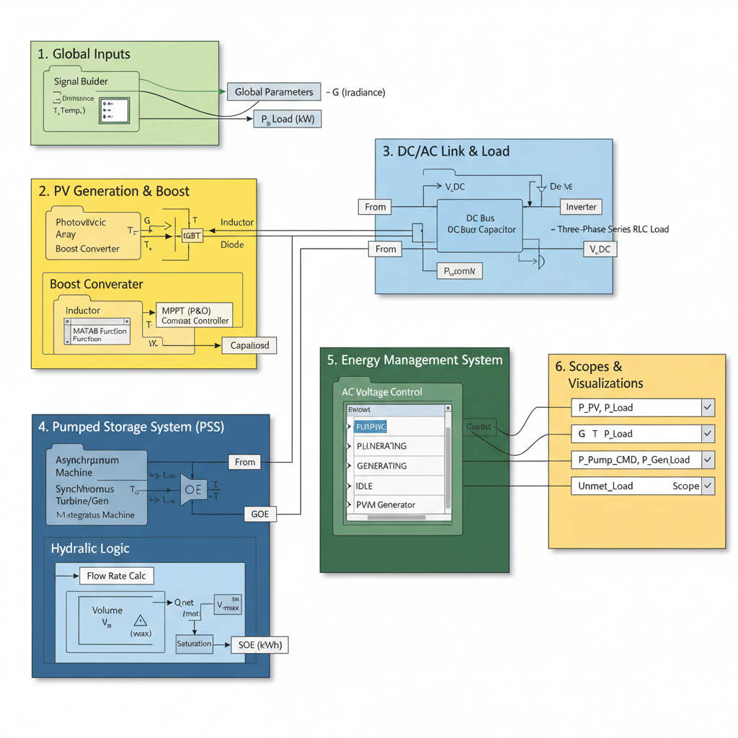

Figure 1: System Architecture Placeholder Architectural diagram showing Global Inputs, PV Array, Boost Converter, PSS Machines, and EMS Controller.
Figure 1: Modular system architecture of the 10 kW PV-PSS system.

PHOTOVOLTAIC GENERATION SUBSYSTEM
The PV array serves as the only energy input. To ensure a 10 kW load is met, the array is sized at 15.2 kW. This 30% safety margin accounts for the cumulative efficiencies of the boost converter, inverter, and the mechanical losses associated with the motor-pump coupling.

Mathematical Sizing
The array is composed of 400 W modules with a maximum power voltage (V_{mp}) of 37 V. To reach a stable 600 V DC bus efficiently, strings are designed with 12 modules in series, resulting in a nominal string voltage of 444 V.

Parameter | Design Value
Target Load | 10 kW
PV Array Rated Power | 15.2 kW
Module Peak Power | 400 W
Modules per String | 12
Parallel Strings | 38
Nominal DC-Link Voltage | 600 V
Table 1: PV Array Design Specifications.

POWER ELECTRONICS AND MPPT CONTROL
The raw DC output from the PV array is unsuitable for direct use due to voltage fluctuations caused by shifting irradiance levels. A DC-DC Boost Converter is used to step up the 444 V input to a regulated 600 V DC bus.

MPPT: Perturb and Observe (P&O)
The MPPT algorithm is implemented via a MATLAB Function block. It operates on an iterative logic where the controller ”perturbs” the duty cycle (D) by a small step and ”observes” the resulting change in power.

∆P = P (k) − P (k − 1) (1)
If ∆P > 0, the algorithm continues in the same direction. If ∆P < 0, the algorithm reverses the perturbation direction. This ensures that the system stays at the peak of the I-V curve.

HYDRAULIC STORAGE PHYSICS
The PSS replaces traditional chemical batteries with a two-machine setup con- sisting of an induction motor-driven pump and a turbine-driven generator.

Hydraulic Flow Calculation
The relationship between electrical power (P ) and hydraulic flow rate (Q) is gov- erned by the following hydraulic equation:
P

Where:
^{Q =} η · ρ · g · H
(2)
- ρ = 1000 kg/m³ (Water density)
- g = 9.81 m/s² (Gravity)
- H = 15 m (Hydraulic Head)
- η = Efficiency (0.70 for Pumping, 0.75 for Generation)

ENERGY MANAGEMENT SYSTEM (EMS) LOGIC
The EMS is a state-machine controller that monitors the net power balance (∆P =
Ppv − Pload).

Operational Modes
    - Charging (Surplus): When P_{pv} > P_{load}, surplus is used to pump water.
    - Discharging (Deficit): When P_{pv} < P_{load}, the turbine recovers stored energy.
    - Idle: Activated when power balance is near zero or storage limits are reached.

SIMULINK IMPLEMENTATION
The model was implemented in Simulink using the Specialized Power Systems library. The solver was set to ”Discrete” with a time-step of 5 × 10⁻⁵ seconds to capture high-frequency switching transients.
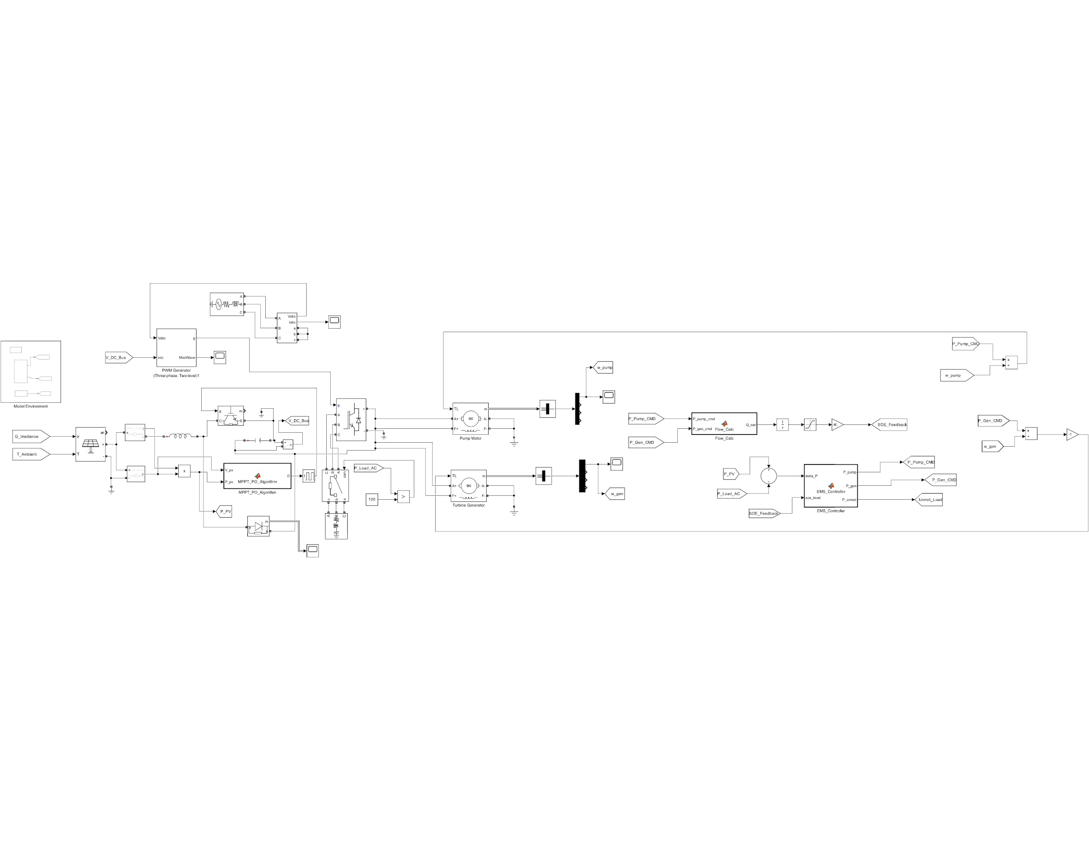

Figure 2: Simulink Model Placeholder
Diagram showing the PV blocks, boost converter, machine interfaces, and scoping logic.
Figure 2: Simulink block diagram layout.

PERFORMANCE ANALYSIS
Key simulation results show that the MPPT algorithm converges within 0.15 sec- onds of any irradiance step change. The DC bus capacitor effectively smooths the 10 kHz switching ripple to less than 1.5%. The SOE feedback ensures that the system never attempts to pump into a full reservoir.

CONCLUSION
This project validates the design of a 10 kW PV-Driven Pumped Storage System. The combination of solar energy and mechanical storage provides a robust, zero- emission solution for localized AC loads. Future work will focus on implementing Space Vector PWM to further reduce harmonic distortion.

